Student Success Services  How counsellors can help  Georgian College’s counsellors can assist and support students through free, confidential services, including:  - Crisis counselling  - Personal counselling  - Information on college programs  - Information regarding college application and admission procedures  - Educational planning  Counsellor records are strictly confidential and can only be shared with appropriate individuals with the signed consent of the student.  For students who are in crisis or who are dealing with time-sensitive issues, on-call counsellors are available either in person or by telephone Monday to Friday, 8:00 a.m. to 4:30 p.m. with extended evening hours Monday to Thursday to 7:00 p.m.  *Note: hours adjusted during holidays and Summer semester  Student Success  Barrie 705-722-1523  Orillia/ Muskoka 705.325.2740 ext. 3113 or 705.329.3113  Owen Sound 519.376.0840 ext. 2099  Midland  South Georgian Bay 705-722-1523 to book an appointment  Orangeville  Ask A Counsellor (e-mail for help)  counsellor@georgiancollege.ca |  |  | 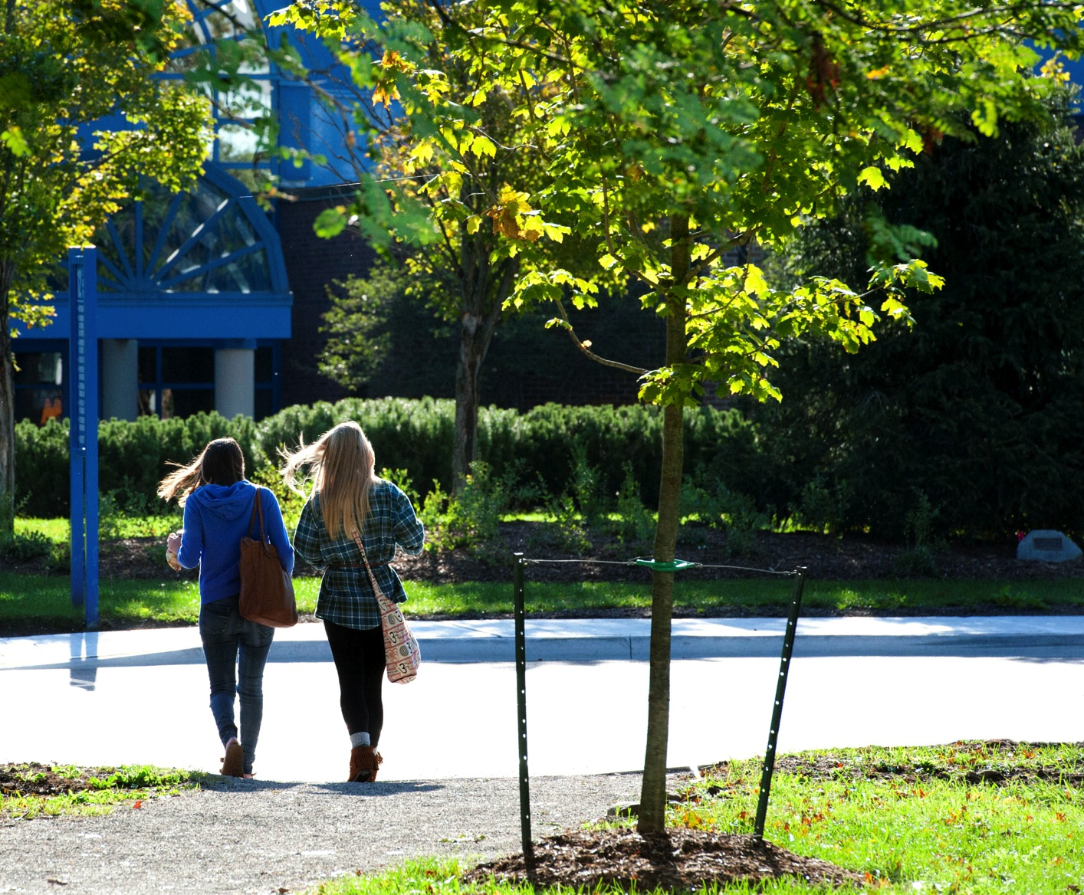  Identifying and Responding to Students in Distress

Faculty and staff are often the first to become aware that a student is in crisis or distress. As an initial point of contact, faculty and staff can be instrumental in helping connect a student to needed support. This folder is designed to help with this important function.  emergency situations  Immediately call 911 and Campus Safety & Security to report any of the following:  THREATS OR DISRUPTIVE BEHAVIOUR drug and alcohol misuse Campus Security Ext 5100 or 705-722-5100 24 hours a day; 7 days a week 911 (Police, Fire, Ambulance)  - Any type of physical violence causing bodily harm (to self or others) - Specific threats of violence or harm - Suicide attempt - Potential drug overdose - Potential alcohol poisoning  crisis Situations  Student Success (during business hours only) or Campus Safety & Security (24/7)  Direct or Indirect Reference to wanting to die/suicide BEHAVIOURs of concern Student Success Barrie 705-722-1523 Orillia/Muskoka 705.325.2740 ext. 3113 or 705.329.3113 Owen Sound 519.376.0840 ext. 2099 Midland/ South Georgian Bay/ Orangeville 705-722-1523 to book an appointment Campus Security Ext 5100 or 705-722-5100 AFTER HOURS Campus Security Ext 5100 or 705-722-5100  Regardless of the circumstances or content, ANY reference to wanting to die/suicide should be taken seriously. Warning signs might include: The student is: - Incoherent or unintelligible - Cannot be calmed  - Expressed feelings of worthlessness, helplessness, or hopelessness  - Expressed thoughts that the world, their family and friends, would be better off without them  - Expressed feelings of powerful guilt  - Expressed desire to die by suicide |  |  |  |  | 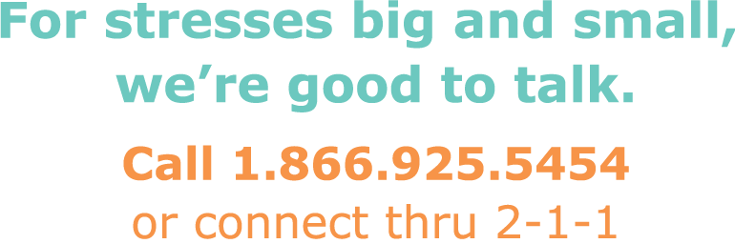  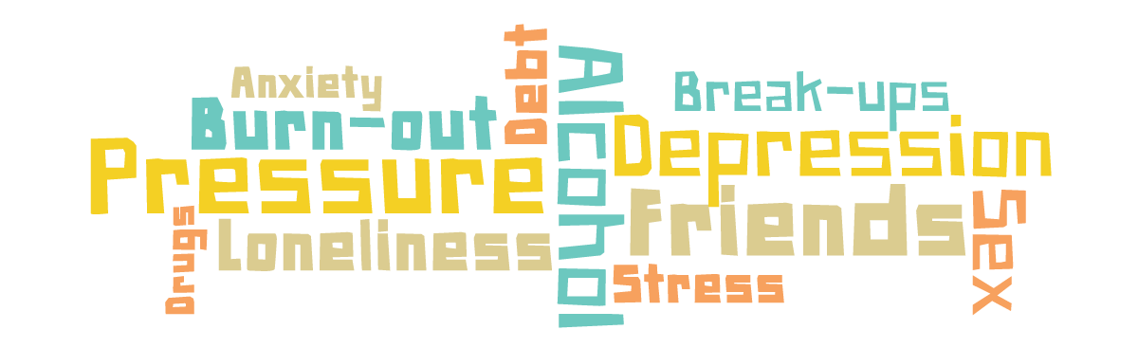
Who to Call  EMERGENCY Life threatening Imminent safety risk to self or others CRISIS Urgent Not life threatening No imminent safety risk to self or others DISTRESS Not urgent Not life threatening No imminent safety risk to self or others  Assault or injury Threat of violence or injury Suicide attempt Intoxication/ Overdose Thoughts of suicide Thoughts of death Unable to be calmed Incoherent or unintelligible Marked change in mood or behaviour Social withdrawal Difficulty with concentration Difficulty communicating Deterioration in physical health, appearance or hygiene Harassment Bullying Discrimination Serious academic concerns In danger of failing Considering withdrawal Known or suspected disability  911 and Campus Security Student Success Services or Campus Security AFTER HOURS Campus Security and/or Royal Victoria Hospital Mobile Crisis Program CMHA Mobile Crises Services Student Success Services Campus Security and/or Student Success Services Faculty Coordinator Centre for Access  Consult with the Student Success Services if you are unsure of how to proceed |  |  |  |  |  |  |  | OTHER SITUATIONS REQUIRING ATTENTION  Contact the resources listed for the following reported behaviours or issues:  Marked changes in mood or behaviour Difficulty in Communicating and/or distortions of reality Disordered eating Assault and/or Harassment learning and academic challenges  - Withdrawal from social interactions or academic work - Notable changes in energy level or appearance - Difficulty communicating (difficulty forming thoughts, completing sentences, irrational conversations) - Distortions of reality - Excessive dieting - Uncontrolled binge eating - Induced vomiting after eating - Sexual assault - Harassment, bullying, physical and/or emotional abuse - Stalking - Discrimination - Serious academic concerns - Considering withdrawal - In jeopardy of failing - Academic accommodation required  Student Success Barrie 705-722-1523 Orillia/Muskoka 705.325.2740 ext. 3113 or 705.329.3113 Owen Sound 519.376.0840 ext. 2099 Midland/ South Georgian Bay/ Orangeville 705-722-1523 to book an appointment Campus Safety & Security Ext 5100 or 705-722-5100 Faculty Coordinators Associate Deans Student Success  Other signs of distress  - Listlessness or falling asleep in class - Physical symptoms (nausea, headaches, problems with eating, excessive or disrupted sleeping) - Changes in hygiene or dress - Significant weight loss or gain - Difficulty concentrating - Unusual behaviour (unexplained crying, laughing to self, rapid speech, disorganized thinking, suspiciousness) - High levels of irritability - Changes in academic performance (deterioration in quality of work, frequently missed assignments and classes, excessive procrastination, avoidance of participation - Changes in relationships or social behaviour (withdrawal, isolation or dependency)
What to Do and Say  Approach - Meet in private (unless it feels unsafe to do so) - Express your concern for the student - Be specific about the behaviour that worries you I’ve noticed you’ve been absent from class lately and I’m concerned about you.  Listen - Stay calm and listen - Give your undivided attention - Try to understand the student’s perspective without being judgemental Can you tell me more? Is there anything I can do to help you?  Support - Take the student’s concerns seriously - Offer hope and support, but be cautious about giving advice It sounds like you’re feeling out of place. You’re not alone; there are resources to help!  Refer - Know your own limits- get other people involved - Refer the student to the appropriate on- or off-campus resources - Offer to contact the resource on the student’s behalf or be with them while they make the initial contact themselves, if appropriate If you’d like, I can call and book the appointment for you while you’re here with me.  Making a Good Referral  - Research resources to ensure that they are appropriate. Consult with a counsellor if you are unsure of how to proceed  - Provide the student with information to take away (Good2Talk Card, referral contact information, etc.)  - Offer to follow up with the student, if appropriate  If a Student Says “No” to a Referral  - If there are immediate concerns about safety, call 911 and Campus Security ext. 5100  - If it is not an emergency, respect their right to refuse help  - Keep the lines of communication open  I respect your decision.  I hope you will keep these options in mind.  My door is always open. |  |  |  |  |  | Resources  COUNSELLING and WELLNESS Other Campus Resources Academic Community (24/7 services)  Student Success Barrie B110 705-722-1523 Orillia/ Muskoka A200 705.325.2740 ext. 3113 or 705.329.3113 Owen Sound C607 519.376.0840 ext. 2099 Midland/ South Georgian Bay/ Orangeville 705-722-1523 to book an appointment Campus Safety & Security Ext. 5100 Aboriginal Resource Centres 705.728.1986, ext. 1318 Co-op and Career Services Barrie 705.728.1968 ext 1340 Orillia 705.325.2740 Owen Sound 519.376.0840 ext. 2043 Financial Aid Ext 2457 705.728.1968, ext. 5267 International Students Academic Counsellor 705.728.1968, ext. 1229 Residence Campus Living Centres (CLC) 705.730.5600 Food Locker Program Pride@Georgian Centre for Access and Disability Services Barrie 705.728.1968 ext. 1523 Orillia 705.325.2740 ext. 3113 Owen Sound 519.376.0840 ext. 251 Orangeville, South Georgian Bay, Muskoka, and Midland campuses 705.526.3666 ext. 3720 School of Business, Automotive and Hospitality Ext. 1269 School of Liberal Arts and Access Programs Ext. 1315 School of Technology and Visual Arts Ext. 5237 School of Human Services and Community Safety Ext. 3061 School of Health and Wellness Ext. 1163 Canadian Mental Health Association, Simcoe Crisis Services 705-726-5033 Royal Victoria Hospital 705-728-9802 Ontario Mental Health Helpline 1-866-531-2600 Telehealth Ontario 1-866-797-0000 TTY-1-866-797-0000 Barrie Police Services 705-725-7025 (non-emergency) 911 (Police, Fire, Ambulance) Good2Talk 1-866-925-5454 Athena's Sexual Assault Counselling and Advocacy Centre 705-737-2008  PEER SUPPORT AND TUTORING  Peer Services  Barrie  705.728.1968 ext. 1046  Orillia  705.325.2740 ext. 3036  Owen Sound 519.376.0840 ext. 2051  Academic Success Centre  Learning Strategists  Barrie K112 or call  705-728-1968 ext. 1307  Orillia A200 or call  705-325-2740 ext. 3113  Owen Sound  Rm. 607 or call  519-376-0840 ext. 2099

